Bridgepoint Parts Catalog

Section XV: RX-20 Parts Page 1

PHY169-058 Valve – Hydramaster SS

Wand / RX-20

Repair Parts:
Stem Assembly: PHY012-002
O-ring Kit: 100012
Cap: PHY027-001
Spring: PHY155-003

PHY604-052-006

Motor – Electric

High Speed RX-20

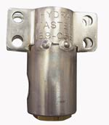
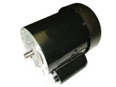

PHY178-004

Power Cord – 14-3 x 50’

with Grounded Plug

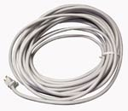

PHY154-001

Spacer 1/4” X 5/16” SS

Valve Mounting

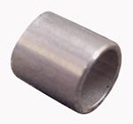

NM5038

Strain Relief – Cord Grip

Black Plastic
Hydramaster part # 108-012

Replacement back-up nut: NM5039

PHY167-009

Trigger – RX-20 Solution Valve

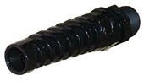

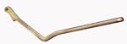

PHY107-103

Pivot RX-20 Trigger

PGR01

Strain Relief – Metal-Wire Mesh

Power Cord Grip

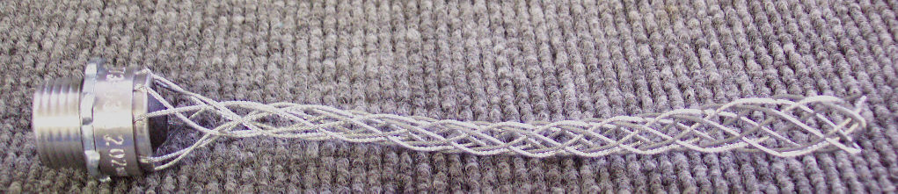

PHY052-276

Rotary Union – RX-20

1/8” MPT

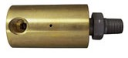

PHY157-032

Microswitch – RX-20 Power

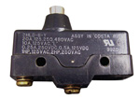

PHY052-001

Swivel Fitting – 2M-2UFS

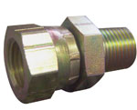

PHY108-014

Shield – RX-20 Microswitch

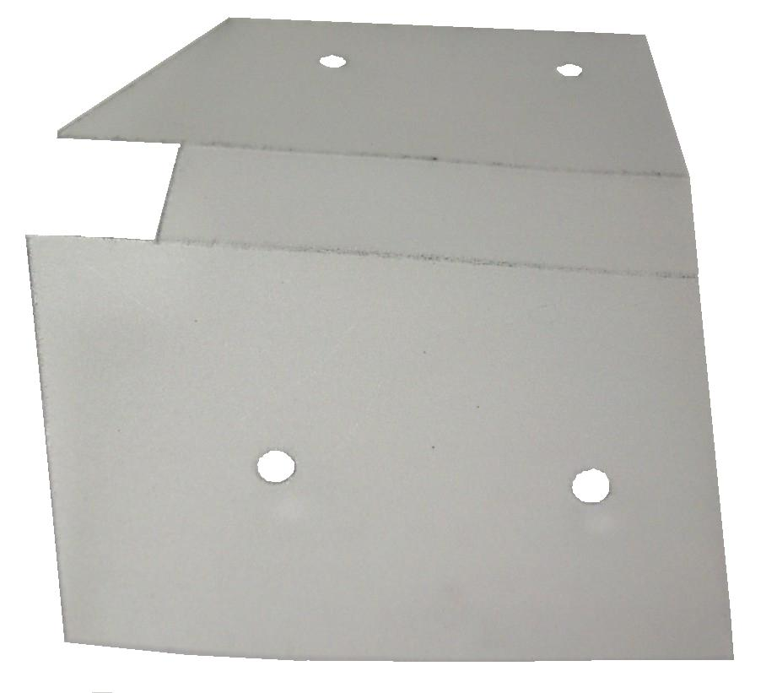

PA065

Y-Strainer 1/4” FPT
(Hydramaster part # 049-033)
Replacement Filter Screen: PHY049-016

PHY167-010

Trigger – RX-20 Power Switch

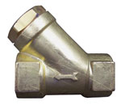

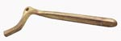

PHY157-111

Switch – Momentary SPST

Push Button - NO

100009

1/4” Male Quick Connect

Brass
(Hydramaster part #052-050)

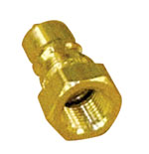
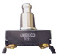

PHY178-039

Power Cord 14/3 x 6’ Extension

High Speed RX-20

Power cord from switch to motor
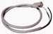

BR072

1/4” Hex Nipple – Brass
(Hydramaster Part # 052-071)

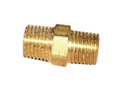

PHY157-033

Switch – Starting

Leeson Motor
High Speed RX-20

PHY068-176

Hose Sol Valve to Rotary Union 3/16” X 45” SS - 1/8” MPT

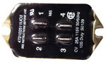
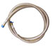

Bridgepoint Parts Catalog

Section XV: RX-20 Parts Page 2

PHY059-001

Gearbox High Speed RX-20

PHY064-012

RX-20 Vacuum Head Assembly

Components:
Vacuum Head: PHY064-011
Skid: (old style) PHY107-095
Skid: (new style) PHY107-245
Gasket: PHY057-048

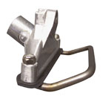
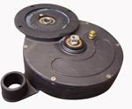

100002

Bushing 1/4” MPT x 1/8” FPT

PHY107-020

RX-20 Hub – with Ring

Double Lead Thread

PHY106-014

Vent Plug – 1/8” MPT
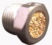
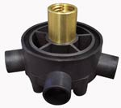
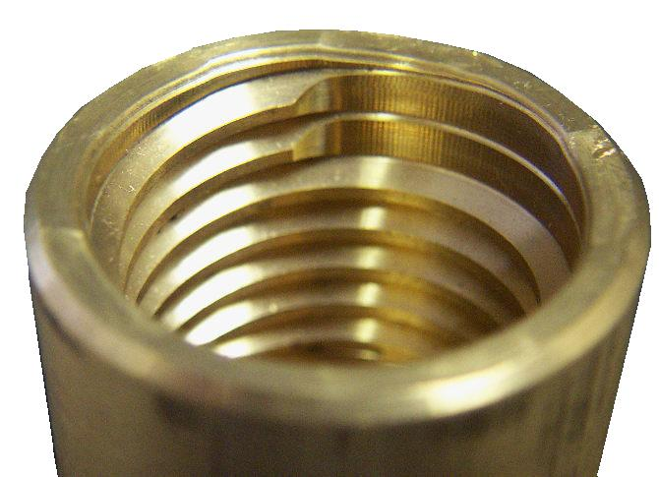

PHY147-015

Oil Seal – Threaded Shaft
High Speed & Low Speed RX-20

PHY107-022

RX-20 Hub – with Ring

Single Lead Thread

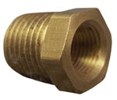
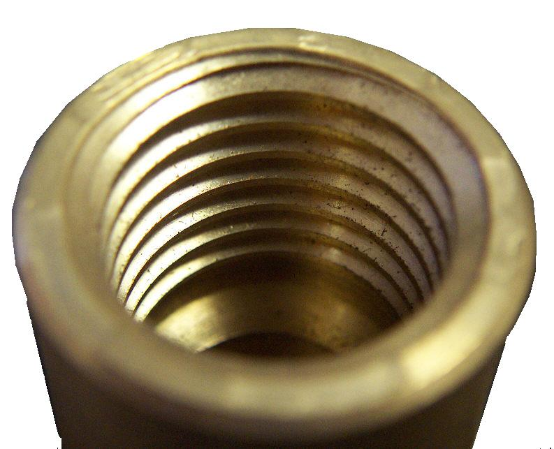

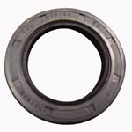

Discontinued PHY052-080

Nipple 1/8” x 4” Brass

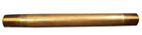

PHY147-019

Oil Seal – Top Shaft Seal
High Speed RX-20

PHY052-515

Nipple 1/8” x 4” Stainless Steel
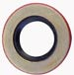

PHY052-089

Elbow 90° 1/8” F-F Brass

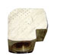
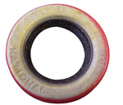

PHY147-018

Oil Seal – Motor Shaft Seal
High Speed RX-20

PHY107-089

RX-20 Star Plate

Heat Treated Stainless Steel
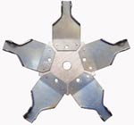

PHY078-007

Oil Seal Replacement Kit
Low Speed RX-20

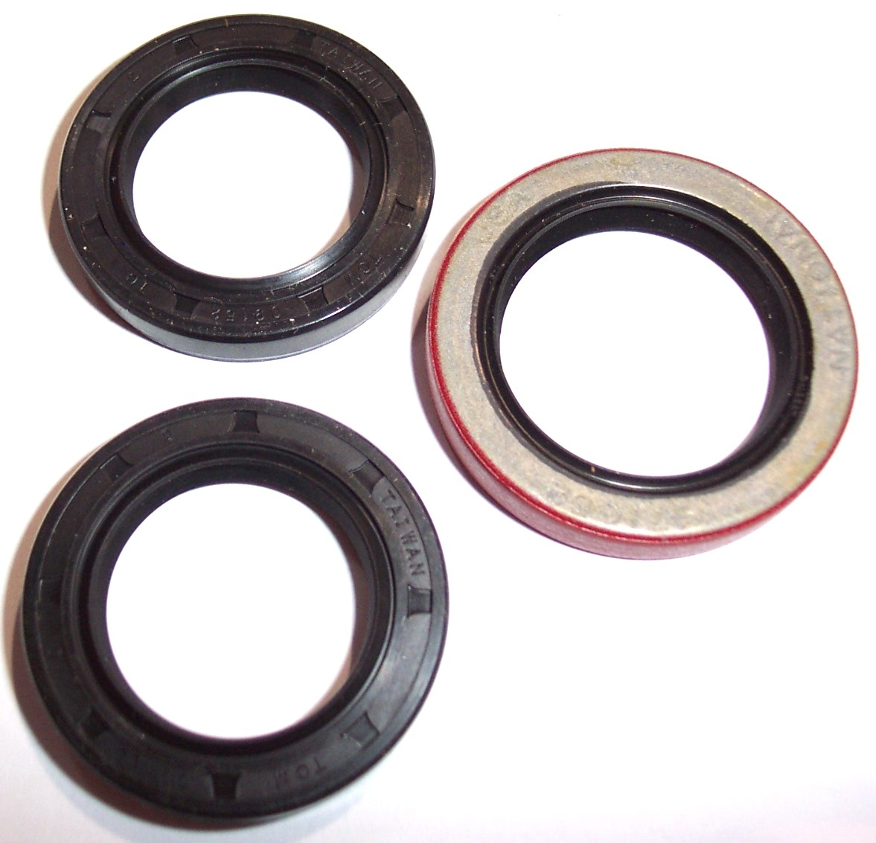

PHY078-067

Star Arm Replacement Kit

PHY147-016

Oil Seal – Worm Drive Shaft
Low Speed RX-20

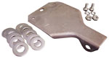
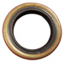

PHY097-009

O-ring Rx-20 Shaft Seal

PHY068-174

Vacuum Hose – 1” x 8”
RX-20 Hub / Skid

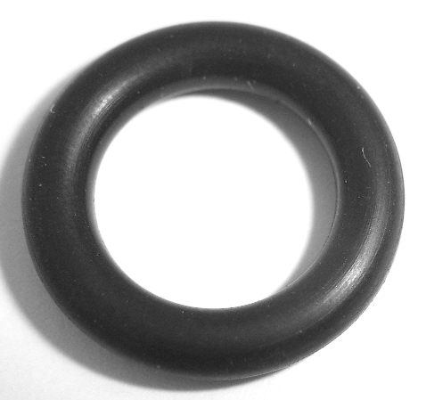
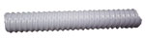

PHY057-047

Felt Gasket – RX-20 Hub Seal

PHY105-008

Plate – RX-20 Hub Seal

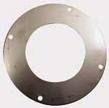
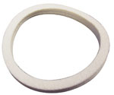

Bridgepoint Parts Catalog

Section XV: RX-20 Parts Page 3

PHY068-193

Vacuum Hose 2” Clear
Sold by the foot

BR220

Plug 1/8” Brass
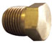
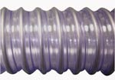

BR110

Coupler 1/8” F-F Brass
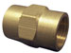

PHY006-009

Base – High Speed RX-20

BR270

Elbow 45° 1/8” Street M-F

Brass
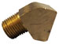

PHY061-017

Handle – High Speed RX-20

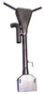

BR175

Adapter 1/8” M-F - Brass

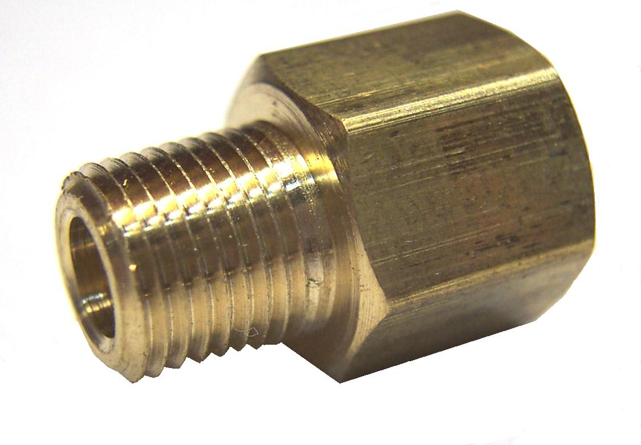

PHY033-114

Clamp Linkage Handle Adjusting Assembly
High Speed RX-20

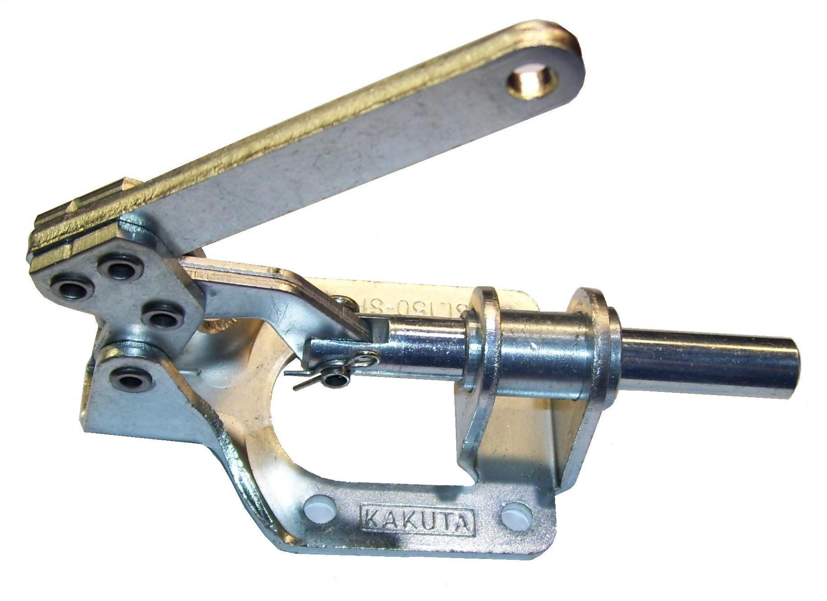

PHY041-013

Access Cover - Handle

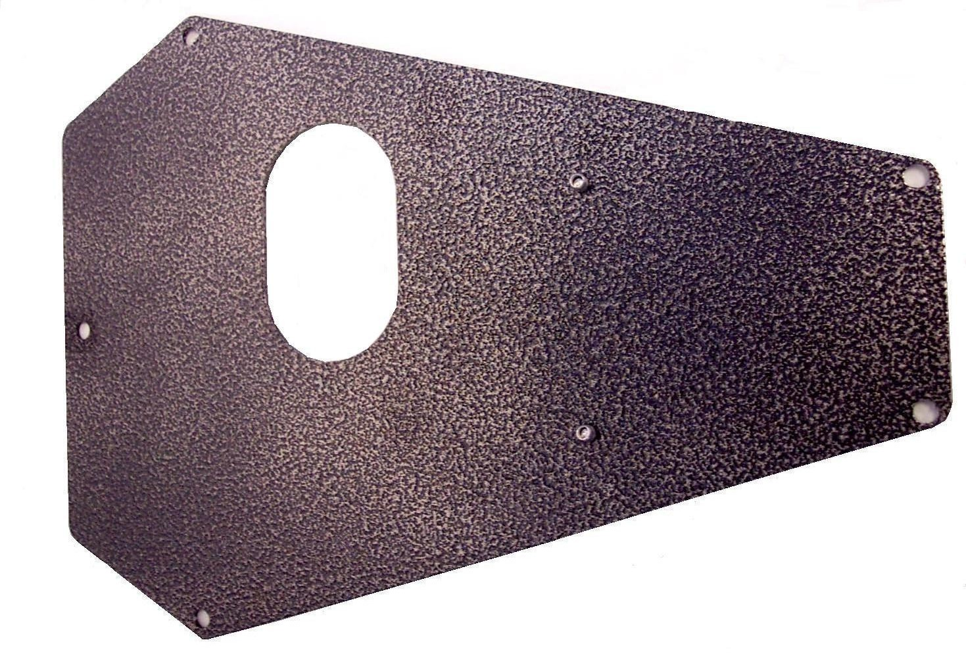

PHY041-017

Cover – Side Port
Low Speed RX-20

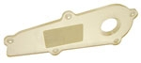

PHY015-009

Bracket RX-20 Handle Brace

Discontinued High Speed RX-20

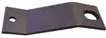

PHY006-008

Base – Low Speed RX-20

with side port

PHY015-066

Bracket RX-20 Handle Brace

Discontinued

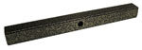

PHY061-027

Lift Handle - High Speed RX-20
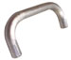

PHY015-006

Bracket RX-20 Handle Brace

High Speed RX-20

(Replaces PHY015-009 & PHY015-066)
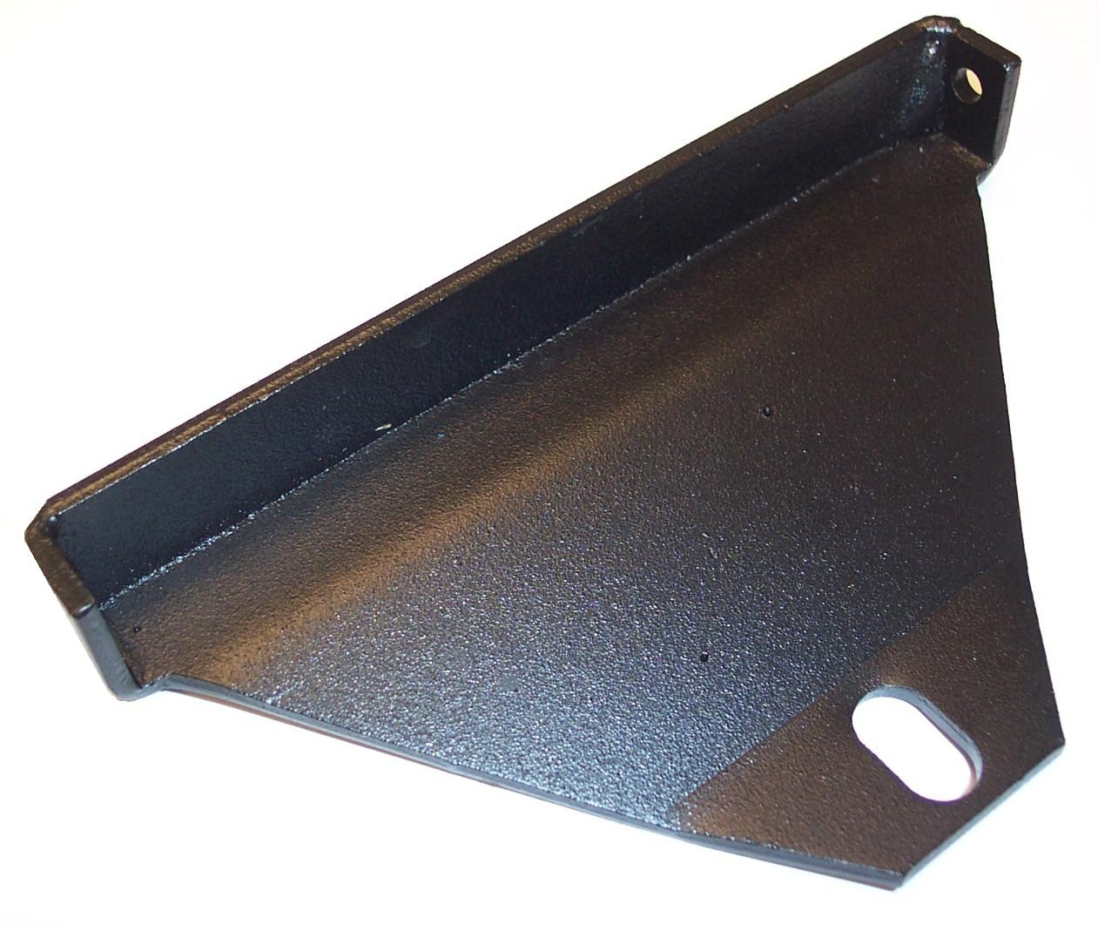

PHY015-139

Bracket – Handle Brace

High Speed RX-20

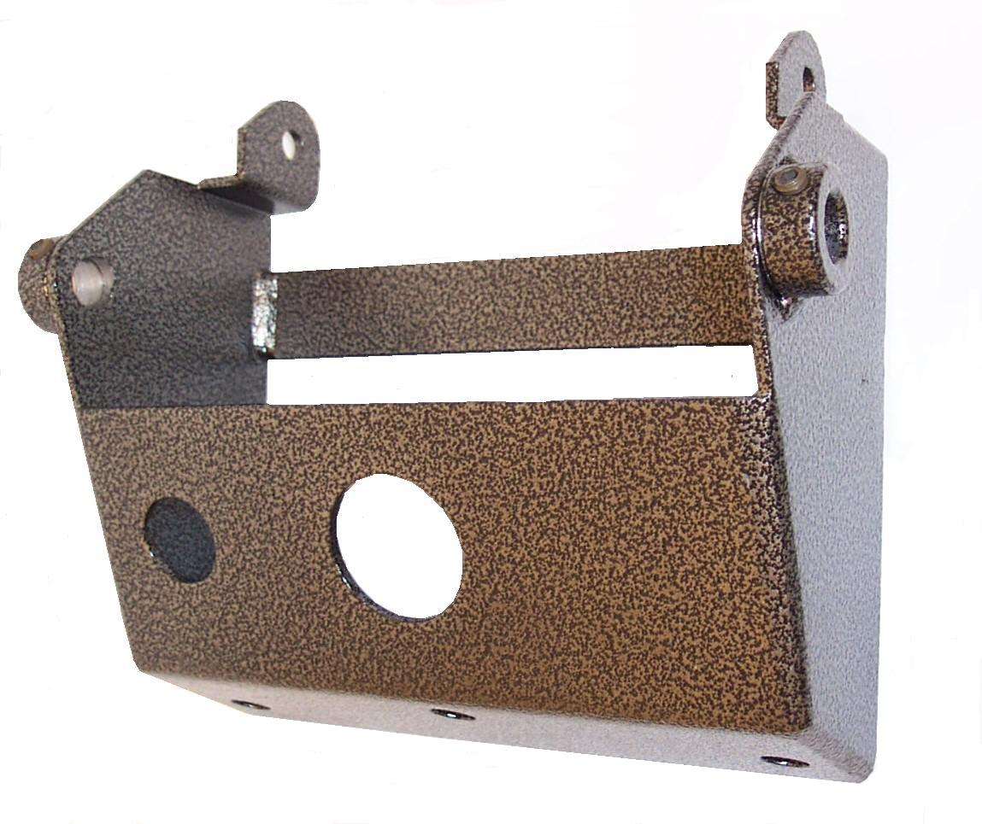

PHY143-012

Screw 5/16-18 x 3/4” SS HHC

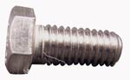

PHY157-042

Switch – Relay 110VAC

High Speed RX-20

Safety Start

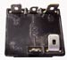

PHY143-166

Screw 10-24 x 3/8” SS HHC

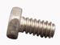

PHY164-014

Wrench RX-20 Head Removal

PHY078-108

Shroud Bumper Kit

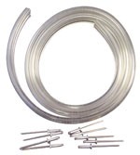
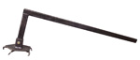

Bridgepoint Parts Catalog

Section XV: RX-20 Parts Page 4

PHY141-002

Adjusting Rod - Handle
Low Speed RX-20

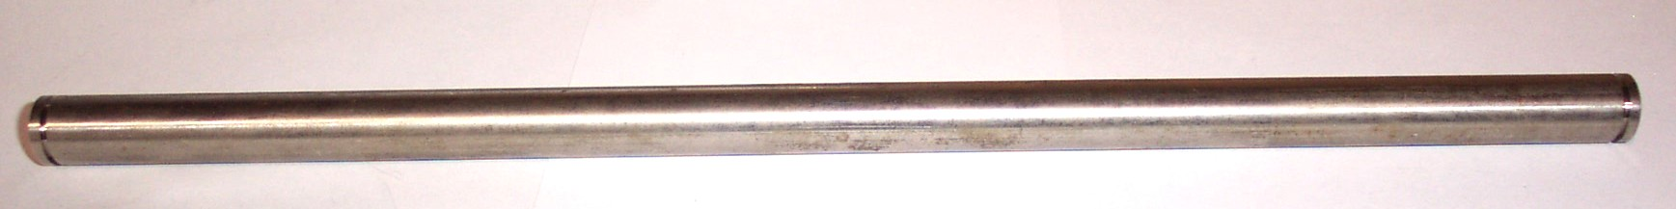
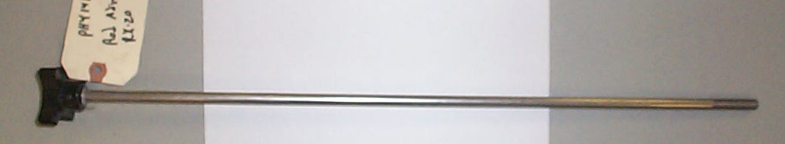

PHY141-006

Adjusting Rod Assembly
High Speed RX-20

PCE40-06
8” Wheel – High Speed RX-20 Hydramaster Part # 177-001

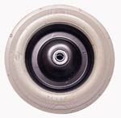

PHY061-015

Knob - Handle Lock

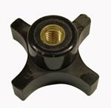

PHY139-009

Snap Ring 1/2” E-Clip

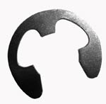

PHY020-004

Set Collar – 3/8”

PHY141-005

Rod – Handle Arc
High Speed RX-20

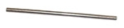
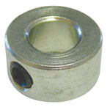

PHY141-004

Axle – High Speed RX-20

PHY103-014

Roll Pin - Handle Lock

PHY139-010

Snap Ring 5/16” E-Clip
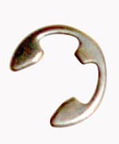

PHY094-030

Adjusting Nut - Handle Lock

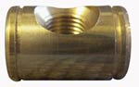

PHY081-001

RX-20 Decal Set – 3pc

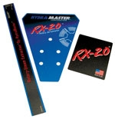

PHY107-101

Plunger - Handle Lock
Old Style - Longer

PHY107-256

Plunger - Handle Lock
New Style - Shorter

PHY076-076

Full Cone Jet – Stainless Steel

1/8GG-SS1
Replacement Vane: PHY076-078
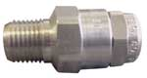
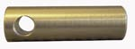

PHY103-012

Clevis Pin 1/4” x 7/8”
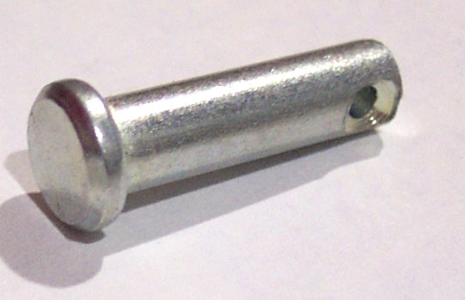

B304

VeeJet – Stainless Steel

H1/8VV80015
Standard RX-20 Jet
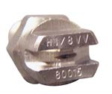

PHY107-096

Handle Arc

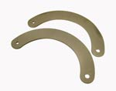

B302

VeeJet – Stainless Steel

H1/8VV8001
Alternate Low Water Use RX-20 Jet

PHY107-097

Link – Handle Lock

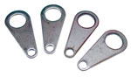
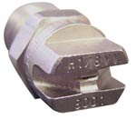

PHY139-006

Snap Ring 5/8” - Handle Lock

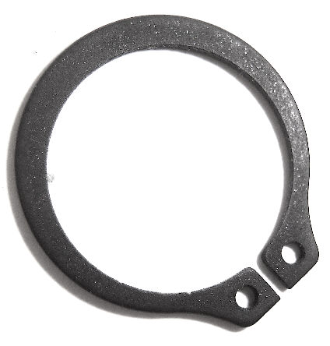

PHY061-004

Foam Grip – Handle

Closed End

PHY061-001

Foam Grip – Handle

Open End

